EMS Well-Being Works
Level II Health Risk Assessment

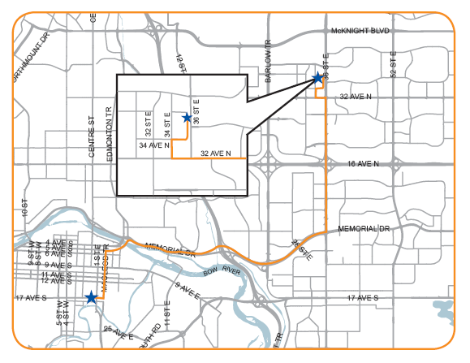

Good Day,

Above is the map to assist you in finding the EMS Well-Being Works Health Clinic located at 3705 35th Street NE. Upon your arrival, please access the Emergency Medical Services entrance and ask the security guard for Stacy. There is available visitor parking, directly out front of the building for your use. If you need to contact me for any reason, please do not hesitate to call my cell phone at 888-2514 for assistance.

Your appointment is scheduled for: march 21st @ 08:30

Also, please remember to fast for 12 hours prior to your Level II Heath Risk Assessment, as this will allow us to achieve the most accurate cholesterol/glucose values. If you are required to take prescription medications and/or vitamins, please do so. Water is acceptable for a fast but…the coffee will have to wait.

Thank you for your interest in remaining, becoming involved with, or making a change in your health. I am looking forward to becoming involved with you in your journey to a healthier, happier you.

Looking forward to meeting with you,

Stacy Goulder

